MINUTES OF THE MEETING OF THE SHILLINGSTONE PARISH COUNCIL
HELD AT 7PM ON THURSDAY 1st OCTOBER 2026 AT THE PORTMAN HALL

PRESENT : Councillors M Pomeroy - Chairman (MP)
K Ridout
R Harwood
R Leadbeater
Clerk S Flack

S Murcer

In addition there were approximately 10 members of the public present.

- Apologies for Absence

Apologies for absence were received from I Suter - Vice Chairman

- Declarations of Interest and requests for dispensation

None

- To Approve the minutes of the Parish Council Meeting held on 3rd September 2026

Minutes Approved by all and signed by Mark Pomeroy - Chairman.

- Matters Arising from Minutes of last meeting

- Traffic timetable/flyer in Parish Magazine.
- Bench at Vale Cottages confirmed as being on Parish Council asset register and is to be assessed by IS.
- Broken bench in play area belongs to Cricket Club not Parish Council.
- Speedwatch equipment now located and address is on the asset register.
- Faulty SID has now been sent off for repair and we are awaiting an estimate of cost.
- Flooding – MP and IS met with Julian Spears regarding the flooding at the A357/Whitepit junction. Julian has agreed to remove the fence in his field and supply a trailer so that MP can clear all the brush to access the ditch. MP is hoping for mechanical assistance from the The Three Okefords Preservation Society or he will have a lot of manual digging to do after the brush clearance.
  - Excess Water leaking at White Pit from a potentially damaged pipe – DC are aware and MP is chasing.
- Local Plan – Response required to be returned to DC before 21.10 - it was agreed by all that MP and IS would draft a response and send it to other Councillors for comment, and reply to DC by the due date.
- Neighbourhood Plan – IS to make last few small changes, return to Philip Reese, and publish on Web Site (and send finalised copy to Clerk).
- Public Session

A member of the public identified themselves and their planning Consultant as being present at the meeting in relation to the planning application under consideration at Lanchards Lane P/FUL/2026/04705 which was to be discussed later in the meeting.

- Report from the Unitary Councillor:
September 2026 Meetings attended:
8 – Members Transformation Group Steering Committee
10 – South West Audit and Governance Committee Forum
22 – Northern Planning Committee
24 – Councillors Budget Briefing
28 & 29 – Audit and Governance Training
30 – Corporate Peer Review – Audit and Governance

Dorset’s Local Plan – Update
DC has begun to prepare a new local plan after deciding to move to the governments new plan making system. The first stage of the new plan began with a scoping consultation to identify the broad issues the LP should address. More detailed consultation will take place in the Spring and Autumn next year giving people the opportunity to comment on evidence, growth options, planning policies and proposed site allocations before the plan is finalised. The expectation is that the plan will be finally adopted between February and August 2029.
All the feedback given as part of the recent consultation under the old system won’t be lost and will be integrated into the new plan.

National Planning Policy Framework Changes – Meeting 5.9.26
Introduces major structural overhaul of planning rules to accelerate housebuilding and streamline development. Strengthens the permanent presumption in favour of development in suitable locations. Establishes a system of gateway tests to determine whether planning decisions are made by planning committees or delegated to officers. The expectation is that far fewer applications will go to committees and ward members will lose their ability to ask for committee decisions.
A copy of the Town and Parish Council briefing slides have been circulated to PC and SM suggested that they were viewed for more details.

Dorset Council’s Q1 Financial Performance
Headlines:
Children’s overspend £3.048m
Adults and Housing overspend £6.771m
Council overspend £8.136m
Savings proving sticky
Children’s and Adult’s savings target £10.707m achieved £3.363m.
Transformation savings £10.118m – achieved £6.118m shortfall £4m.
£8m contingency, £5.155m utilised - £3.5m transferred to Adults.

Service provided by Dorset Council :
SM requested that if anyone has any feedback (good or bad) on the service received from Dorset Council, or indeed if anyone has any issues or concerns, that he would really appreciate hearing about it.

Kay Ridout asked SM to look into a case regarding a tree removal at Vale Cottages that had been refused – SM requested that KR email all the relevant information over to him.

Rob Harwood asked SM if there was any update on the historic case of the unit attached to the Council where there was a misappropriation of funds – SM to report back.

- Street Sweeping / Gullies

Following the request back in July made to RH from a resident asking for the post-harvest straw to be cleared from roads and pavements, it was reported that Shaftesbury Depot came out within 10 days and cleared the roads, but not the pavements, which are also the responsibility of Dorset Council.

MP reported that he had received a reply from DC regarding the clearing of gullies and they had said that gullies would only be cleared on a one-off case by case basis once reported by residents. KR agreed to post a message on Facebook so that local residents were aware of the situation asking them to report individual blocked gullies separately direct to DC. MP requested that perhaps SM could also raise this issue as it seemed a waste of money to do one gully at a time.

- Remembrance Day

Mark Pomeroy had received the wreath for Remembrance Day.

- Councillor Reports

Highways – MP’s report had been distributed and read :
- Gullies issue – see report above.
- A meeting has been arranged with Julian Spears to discuss the culvert at Amber Cottage / White Pit junction.
- Message placed in Parish Magazine regarding legal and considerate parking by all.
- Traffic survey timetable in Parish Magazine.
- SID had now been moved from northern end of the village to Augustan Avenue.

Kay Ridout requested that if anyone had any information of incidences of a silver VW polo driving dangerously could they report it to Dorset police.

SF also requested that ALL Councillors reports were received the week before the Parish Council meeting to enable them to be included in the red ink Agenda that is sent out the previous Thursday.

- Standing Orders

It was agreed to adopt the changes to the wording of the Standing Orders suggested by RL as below :

Add one extra paragraph into section 19 (which is required to cover staffing matters) that states :
H Unless otherwise established, the staffing committee will consist of the Chair and Vice Chair of the Council. Where a grievance is raised that would fall under standing order 19e, then another member of the council should be co-opted onto the staffing committee to handle the issue to resolution.

19e Subject to the Council’s policy regarding the handling of grievance matters, if an informal or formal grievance matter raised by any employee relates to the chair or vice-chair of the Staffing committee, this shall be communicated to another member of the Staffing committee, which shall be reported back and progressed by resolution of the Staffing committee.

It was agreed that RL would make the necessary changes and send the final document to SF.

- Planning Applications

Application Update
Following the extraordinary meeting, the PC is awaiting receipt of artists impressions re Ridgeway Farm P/FUL/2026/03928 before an on-line vote regarding this application is taken, due to the time frame imposed by the planning department, to enable a response to then be compiled and sent to DC by the allotted date.
The draft Minutes from the extraordinary meeting held re the above on 29.9.26 were approved by all for distribution and publishing with no amendments.

New Applications

No Objections :

P/HOU/2026/04599 | 1A Pepper Hill Shillingstone DT11 0TD
P/TRT/2026/04981 | Turnworth Farm DT11 0EE

Discussion took place regarding the development at Lanchards Lane - P/FUL/2026/04705 - and the size of the new agricultural barn was discussed at 20m x 10m with a 6.5m ridge. The differences between an Agricultural application and an Equestrian application were also discussed in relation to this application and the Ridgeway Farm application, as they are in a similar vicinity. It was clarified that Agricultural rules differ considerably to those for Equestrian applications, and that Agricultural applications are treated totally differently to Equestrian applications. It was clarified that there were no high level outside lights in the proposed barn, and that lighting would only be switched on inside the barn as and when required, and that there would be tanks to capture rain water from the roof.
After discussion no objections were raised.

- Finances

The following payments were all approved by all :

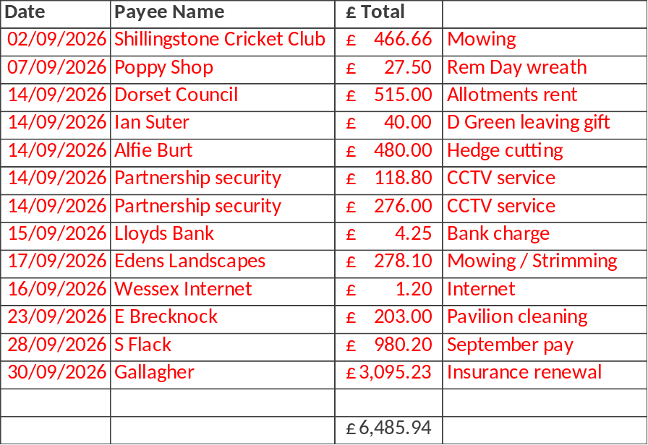

The grass cutting and mowing payments above were clarified and explained following a request at the last meeting by RL, and it was agreed to review all of the Contracts and standing order payments for regular works carried out, and any other regular payments made at the next meeting.

It was also agreed to pay the invoice to Dorset Planning Consultant regarding the Neighbourhood Plan totalling £5148.84, and it was agreed that this money would be deducted from the ERM and taken from the deposit account.

- Budget and Precept

It was agreed to hold a closed meeting after the next Parish Council meeting in November for all to discuss this.

- Recreation Ground, Play Areas and Pavilion report
- Annual report received and quotations requested for highlighted areas potentially needing attention.

- New Clerk Update
- Insurance renewed and price ‘held’ for 3 years
- Training being undertaken discussed.
- Other ‘personal’ items to be discussed with Councillors following the meeting closure.

- Correspondence

The clerk confirmed correspondence had been circulated as below :

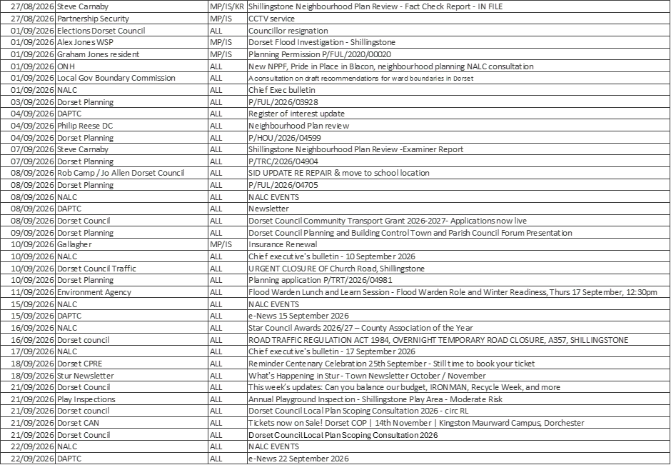

Highlights :
Local Plan scoping consultation – reply to be sent back by 21st October 2026 (MP & IS)
Kay Ridout to complete register of interest update on line

- Items for the next Agenda

- Budget
- Contracts and regular payments
- Transport Survey
- Neighbourhood Plan Update
- Coronation Cup
- Footpaths
- Closed session at end of public meeting

- The next meeting will be held on Thursday 5th November 2026 at the Portman Hall

Meeting closed at 8.20 PM

